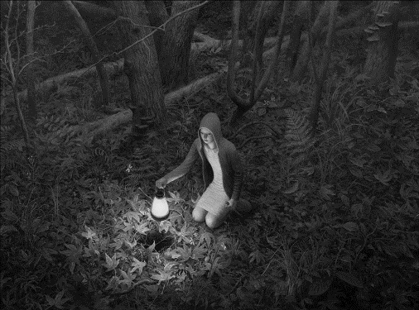1] (Remember, 150 words minimum.)

2] If you didn’t have to come to school every day, how would you spend

your time? Describe what your daily routine would be.

3] Write about whatever you want.